GEOM99 Web Development Log

Step:1

* 6th March 2024,7:10 to 7:12 PM
* First login into the Google account where you have the Google credit -> First log in to <https://console.cloud.google.com/and> -> go then go to the project My First project (I don’t have a project so I created the project -> Go to this project name tab and open -> click to the new project tab fill the details with location No organization.)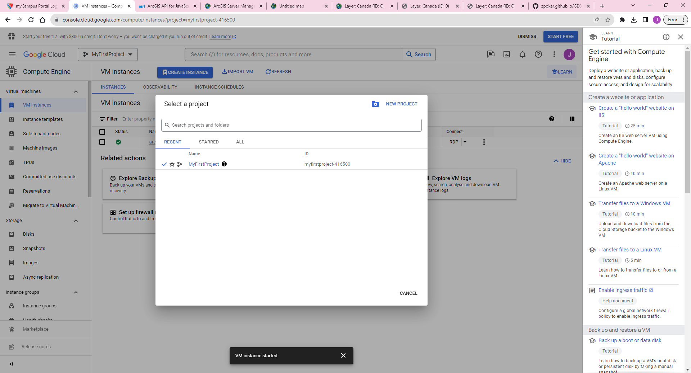

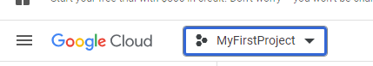

* In the next step I enable the compute engine API and then set the services for this VM.
* Resources: Google Cloud Platform console: <https://console.cloud.google.com/>

Step:2

* 6th March 2024,7:12 to 7:15 PM
* Enables Compute Engine API, which is essential for creating virtual machines on GCP
* Next I go to the  menu and select compute Engine -> VM Instances-> create an instance (click open new window )where I set all the details which are required for this project, most importantly I change the image setting and set it according to the instruction. (Where I go into the custom image settings and select Shawn’s ArcGIS Server, then in the dropdown menu shows the geom992014-v2)
* Next step I enable the firewall services

Step:3

* 6th March 2024,7:15 to 7:19 PM
* First I enable the Firewall services such as allowing HTTP traffic and HTTPS traffic we use this for communication.HTTPS is the secure protocol than HTTP. (HTTPS secures the data before transferring.)
* Hit the create and, it takes a couple of minutes and I have my VM.
* Next step I set the password for my VM.

Step:4

* 6th March 2024,7:20 to 7:25 PM
* After creating the VM I have to set the Password for My VM because of security that anyone can access.

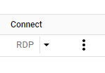

* So, I found out that using the three-dot dropdown menu, I can see the option to set my password. When I clicked on it, a new window opened up and my Gmail ID was automatically populated as the username. However, I changed it to "student" and click on "set" to generate my password.
* Note: I initially set my username as my Gmail ID, but after reading the instructions, I realized that it should be set as "STUDENT". I was unsure of how to change it, so I watched my instructor's video and followed their guidance to update my username accordingly.
* Copy the password and save it in Notepad because it's too hard to remember.
* Resources: <https://youtu.be/dyFeyBX9jIY>
* Next step I set the Firewall Rules for this VM.

Step:5

* 6th March 2024,7:30 to 7:37 PM
* Here I set the firewall rules we set rules for controlling the traffic and preventing unauthorized traffic as well.
* First, I will create the firewall rules. Then, I will set the name as "FLEMINGGRDP444" and set the target as "All instances in the network".
* To set the source filter, select IPv4 ranges. If you're using our system, you'll need to set your system's IP address. However, for this project, we'll set the IP address to 0.0.0.0/0 so that we can access any computer on the internet.
* I need to select the checkbox where I have the option to specify the protocols and port. I will set the port to 444 because I use the on-campus system and this port is set as the default for the custom image virtual machine. For remote desktop protocol (RDP), the default port is 3389.
* Click Create.

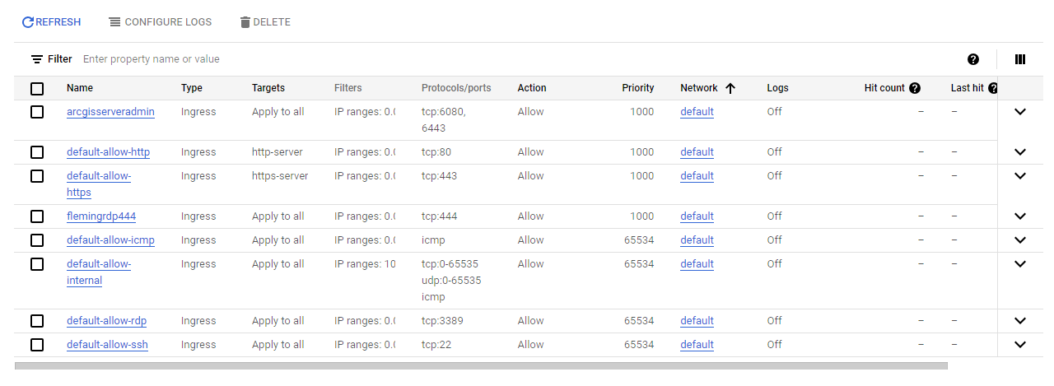

* The next step is to set the firewall rules for the ArcGIS server.

Step:6

* 6th March 2024,7:37 to 7:41 PM
* I set the firewall rules for our ArcGIS server because Google does not open the ArcGIS server port by default. To set up the port, I followed the same process I used for setting up Fleming College port 444. However, in this case, instead of writing port 444, I had to write ports 6080 and 6443.
* Click Create and it takes minutes to load.
* By default, ArcGIS Server supports communication through the 6443 port, and the 6080 port is no longer used for communication in ArcGIS Server. However, we may still use it for testing purposes.



* I set all the settings required for the VM

Set Firewall Rule in the window to allow ArcGIS management ports

Step:7

* 6th March 2024,7:41 to 8:00 PM
* First I login to the VM in the window using Remote Desktop Connection

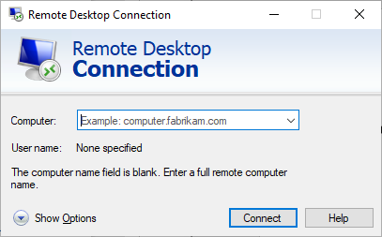

* Login with the External IP address and then pop u7p a new window where I select to use a different user and add username STUDENT and password which we set while setting the VM and when I log in to new windows it takes a few minutes to load.

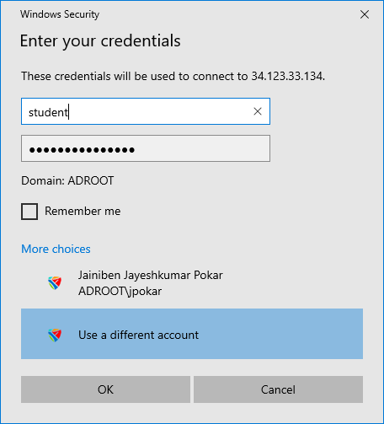

* Next I go into the taskbar search option a search ”Firewall “The one open will appear like Windows Defender Firewall with Advanced security -> select that open one window like below -> next select the Inbound Rule from the left side content bar once clicked on it on the right side we can see the item bar than select New Rule form there.

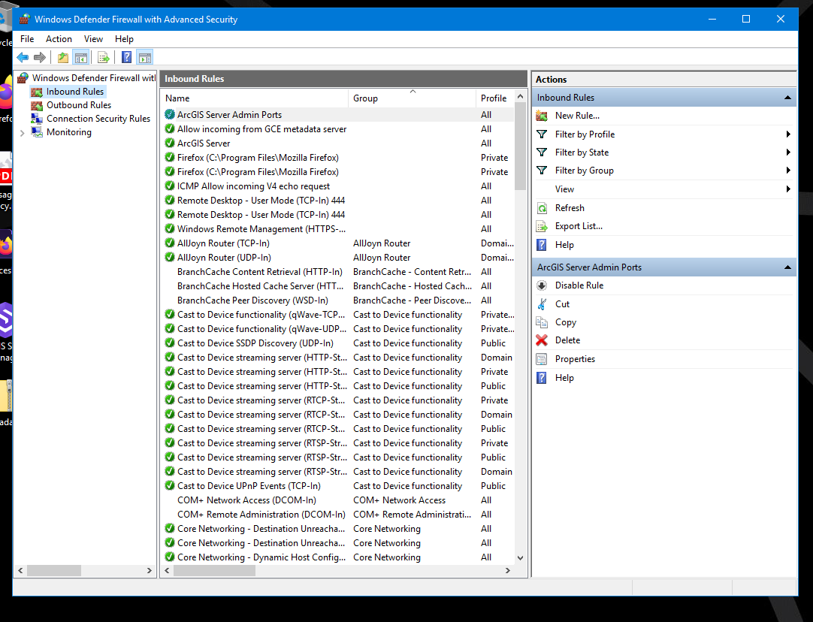

* Once we select open new window there first set the rule type there I select port -> then the next step will appear there I select TCP(we select the TCP port because we used the TCP port ) after selecting the TCP port we have added the port number their I add 6443 and 6080 than click Next Button new setting more ap their we don’t have change anything because it is correct so again click next.
* Then give the name to the rule “ArcGIS Server Admin” and click FINISH.
* Here I am done with setting the rule for the ArcGIS server in VM Window.
* Next step I go back to the original window and try to open the link and check how it works.

Step:8

* 6th March 2024, 8:00 to 8:07 PM
* Next I try to open the ArcGIS server link <https://34.135.95.123:6443/arcgis/services> here I use the 6443 port because without that this link is not working and once we stop the VM our Ip address will change so we have to change the Ip address every time if we stop and start the VM.
* Once I go on this link it shows the window with an unsafe message like YOUR CONNECTION IS NOT PRIVATE below this line there is one button Advance once I click that button new message will appear and then I click on proceed to *IPNUMBER*
* Then open my ArcGIS Rest services.
* Next try to open the ArcGIS Manager [https://34.135.95.123:6443/arcgis/manager](https://34.135.95.123:6443/arcgis/managers) -> once I open this link we have to go to the same process as the one we did in the services link (about unsafe massage) then one login window appears there We have added the username STUDENT and password which we set while setting the VM.

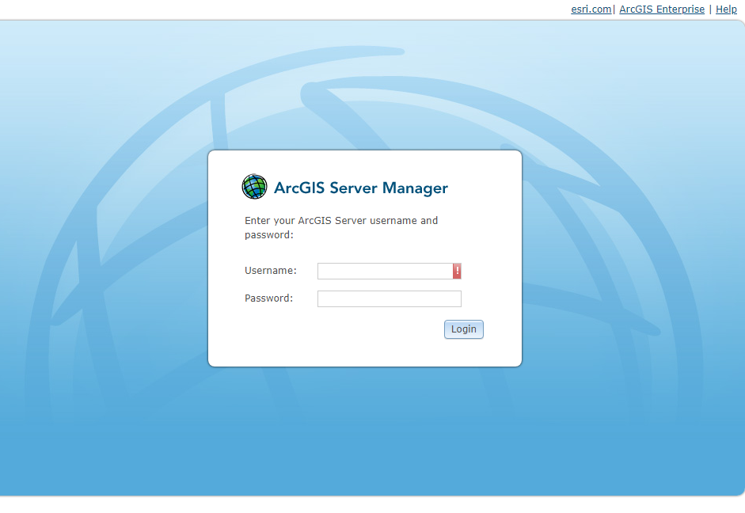

* Next step I go back to the original window and Stop VM.

Step:9

* 6th March 2024, 8:07 to 8:10 PM
* Next I stop the VM -> go to the Google Cloud Platform and on the VM instances then again go to the third dot menu where we set the password for the VM now I select the Stop option and click In a couple of minutes my VM will Stop(if I didn’t shut down my the remote Desktop connection than its automatically close once I stop the VM)
* Now I am again on the VM Machine and publish the map on the ArcGIS server.

Step:10

* 6th March 2024, 8:10 to 8:35 PM
* After starting the VM, again I login into the Remote desktop Connection, and then the remote window on the Desktop there is one Canada folder-> copy that folder content and paste that into this(C:/gisworkspace/Canada ) directory.

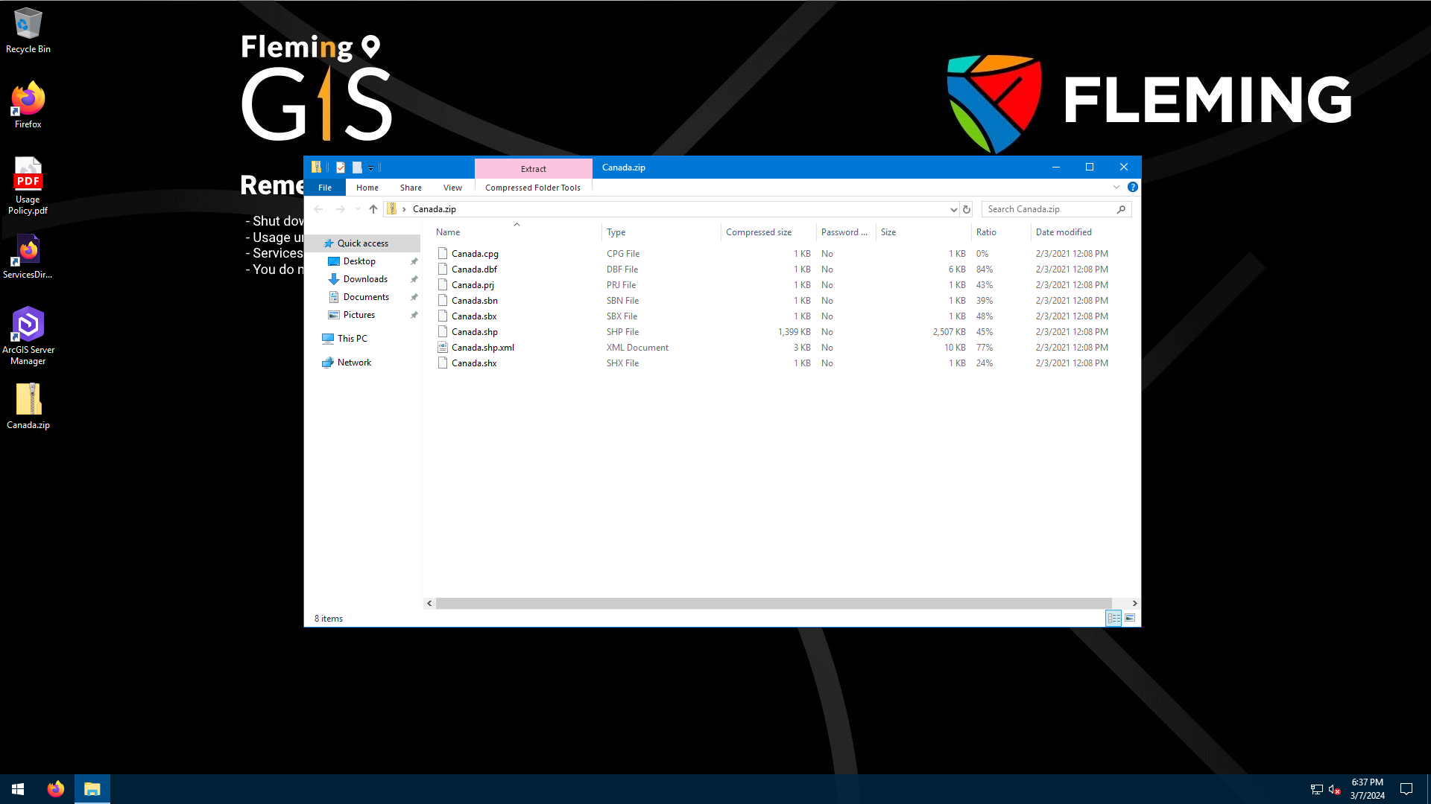

* I started by creating a new project in ArcGIS Pro. Then, I added the Canada shapefile to the map. Next, I decided to change the cartography of the map. Then, I went to the Insert tab and clicked on Connection. From there, I clicked on Server and then clicked on New ArcGIS Server. This opened a popup window that allowed me to add a new server. (I already have the necessary file in my "c:/gisworkspace/canad" folder, as I used it in the past week. If you need to download it then download it from the week 7 checklist, make sure to save it in the same directory on your C drive.)

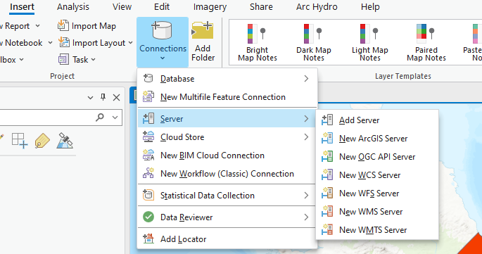

* In the pop-up window, add the Server URL. I should make sure to use the external IP address from VM [https://34.135.95.123:6443/arcgis](https://34.135.95.123:6443/arcgis%20) and provide the username and password which were provided in the week 7&8 checklist for authentication. Once I have added the credentials, I will click on OK.

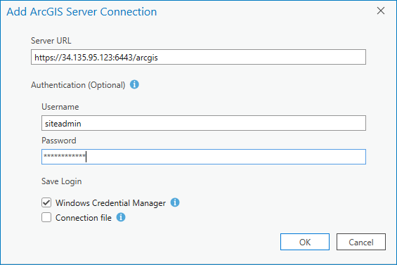

* After clicking OK, a pop-up window appears regarding the certificate. If you click on "View Certificate" (as shown in the picture below), simply close the certificate and click "Yes". It may take a minute, but afterward, you should be able to see the server connection in the Catalog pane, under the server folder. ( arcgis on 34.135.95.123_6443 (1).ags )

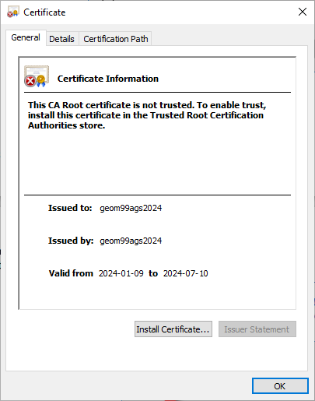

* To publish my map, I first had to find the server connection in the catalog pane. Once I found it, I right-clicked on it and opened a list menu. From there, I selected "Publish" and navigated to the map. Open one new popup window then click on the map from your ArcGIS project, and then click "OK" to confirm my selection.

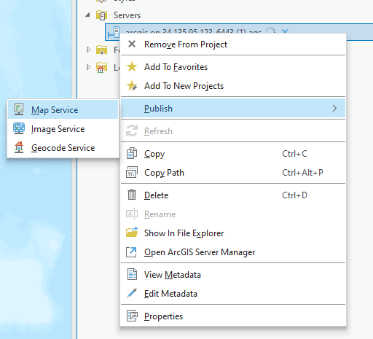

* After clicking new content come in the catalog pan there we have to add the name, description, tags, and folder name then click analyze.

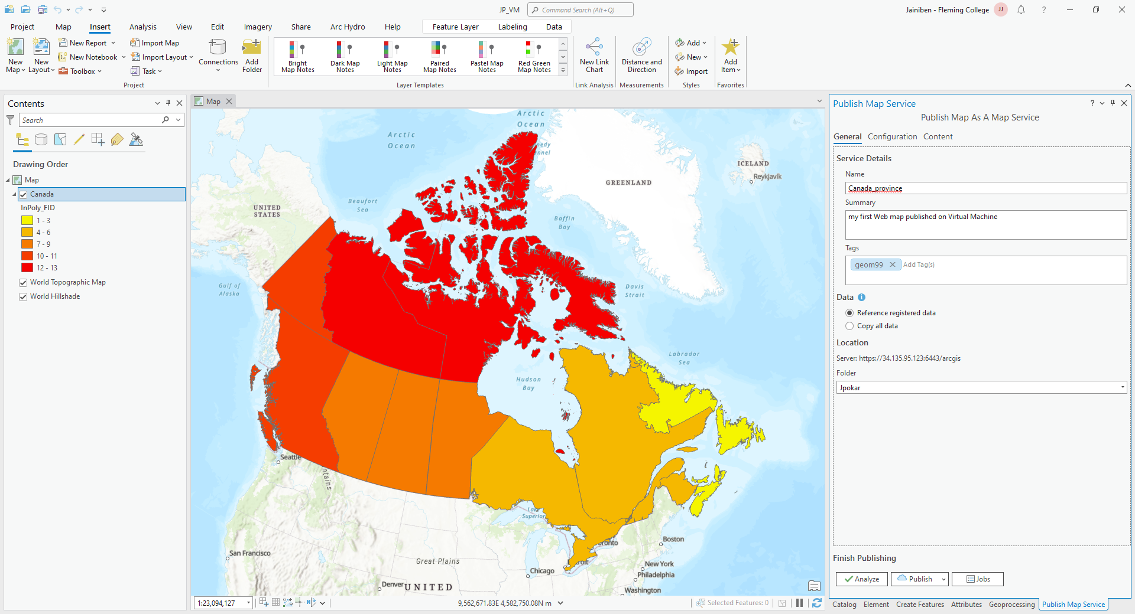

* Once I proceed, I may encounter an error message. One of the errors could be related to a unique sequentially ID, which can be resolved by right-clicking on the error and selecting the "auto-assign ID" option. This should resolve the error and allow me to continue with the task at hand.

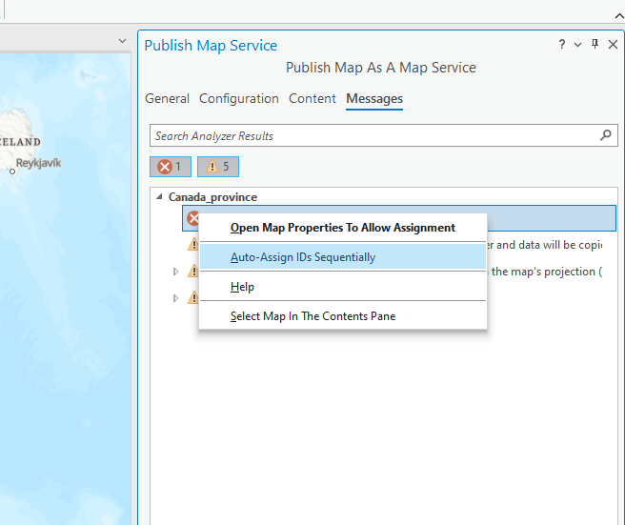

* I have encountered an error regarding data source registration. To resolve this error right right-click on the error then select the first option, provide the C:/gisworkspace path, and click "OK" to make the error go away. Although, I may encounter a warning about the base map projection which I'm not sure how to resolve. Once the issues are resolved, I can simply click "Publish" and wait a few minutes until it completes.

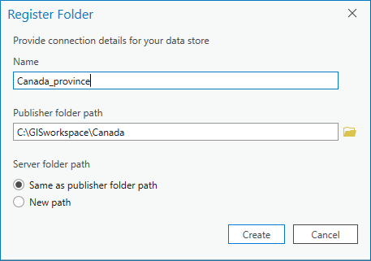

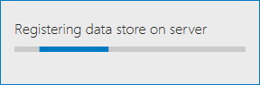

* After selecting the map and confirming my selection, it took a couple of minutes for the data to publish on the server. However, once the process was complete, the map was successfully published and available for others to access.

Step:11

* 6th March 2024, 8:35 to 8:38 PM
* After that we can see that published map on the rest service directory there you can see the folder name that you provided while publishing the folder URL<https://34.135.95.123:6443/arcgis/services>

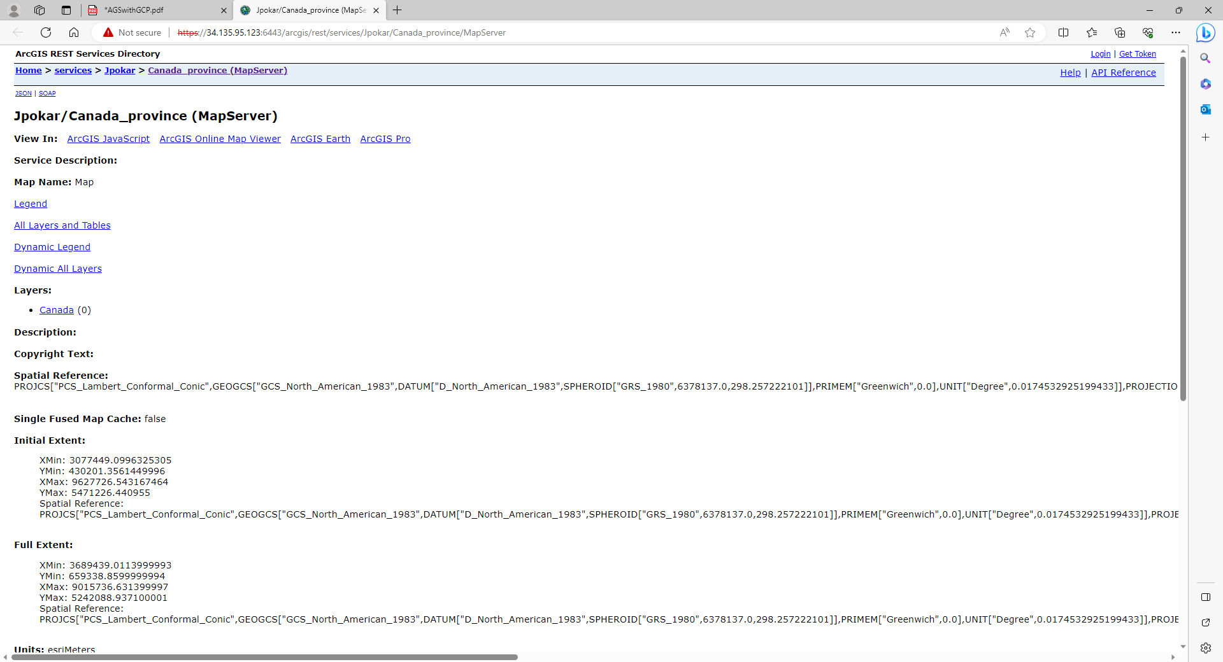

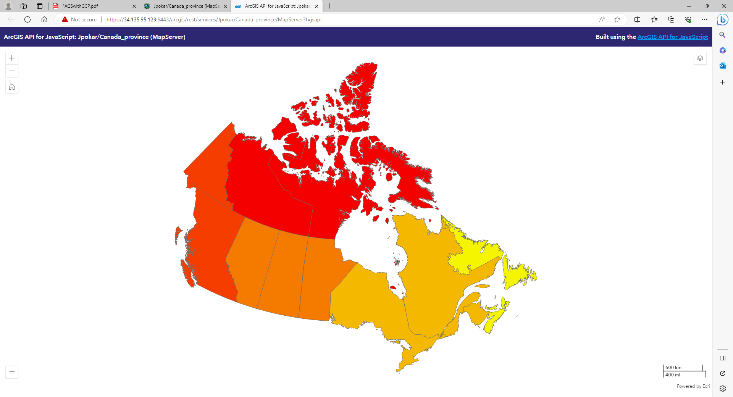

Published map services add on arcGIS online

Step:12

* 6th March 2024, 8:38 to 9:30 PM
* So, I wanted to create two web maps using a published map rest service URL. I first accessed ArcGIS online and went to the content section. From there, I clicked on the 'new item' option and selected the URL. This opened up a new window where I had to copy the URL, one with a 6443 port and the other without a 6443 port. Finally, I was able to create two web maps using this process.
* (here I faced one error I opened the rest directory without opening the remote desktop so it showed an error than login into the remote desktop and open the URL then do this step)
* After copying the URLs, I clicked on the 'next' button and was prompted to enter the title of the map along with tags and a summary. Once I entered all the required details, I clicked on the 'save' button to save the changes.

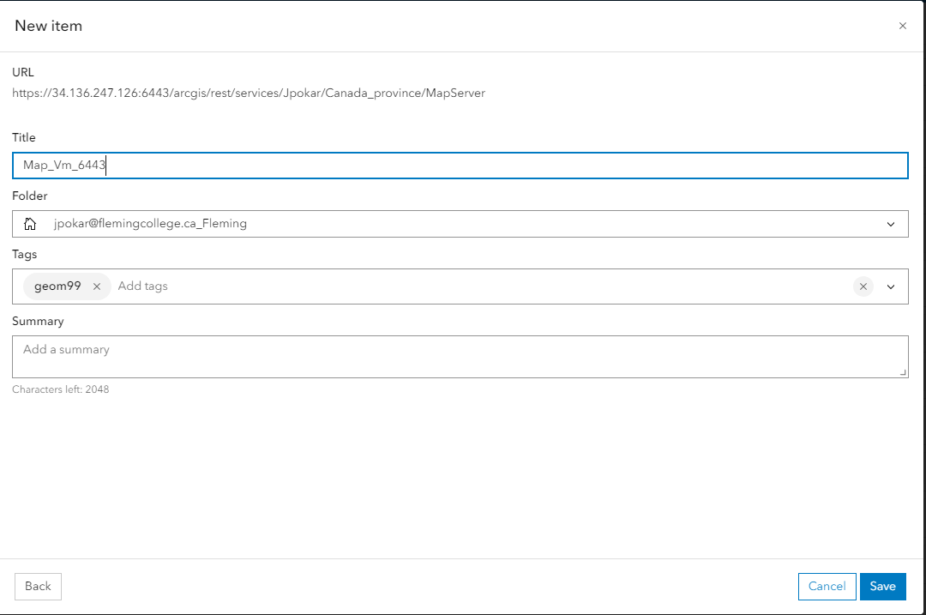

* Map Without port number: <https://fleming.maps.arcgis.com/apps/mapviewer/index.html?layers=cfba86fa068341689b269e10bb95b0ec>
* Mao with port number: <https://fleming.maps.arcgis.com/apps/mapviewer/index.html?layers=5643d7c7e6934988aea20c41d6672755>

Total Time: 2 hours 20 minutes